“Don’t wish for it work for it!”
DaiV’ion Simpson worked hard all day today on 1/9/12. He finished all of his tests in the morning, and now is in the city council room. He didn’t wish for it, he worked for it!
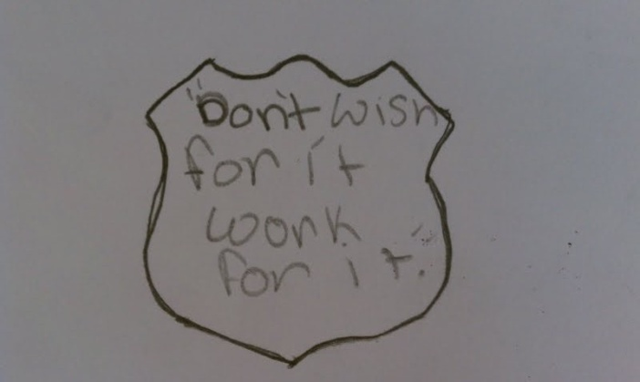

Some people want it to happen, some people wish it would happen, others make it happen.
Today 1/10/12 Casjmier Malone finished all of her centers, and began doing 1/11/12 centers. She is still doing her job as a tutor. Also Akiba Small’s keeping students that are not done with their centers to make sure that they get them done. They made it happen.
This quote means that people wish it would happen but don’t do anything about it and don’t stand up. Some people want it to happen but don’t stand up for what they want. Others work for it to get there and stands up!
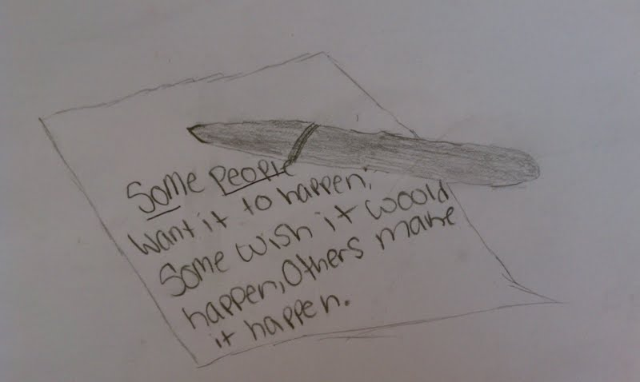

Fall seven times stand up eight.
Tamar rarely finishes all his centers. 1/11/12 he finished all of his centers, and is now in the city council meeting. He even began doing centers for the next day Tamar is an example of a student who fell but stood up! He started the day with a cool down sheet and finished the day as one of the top in the class.